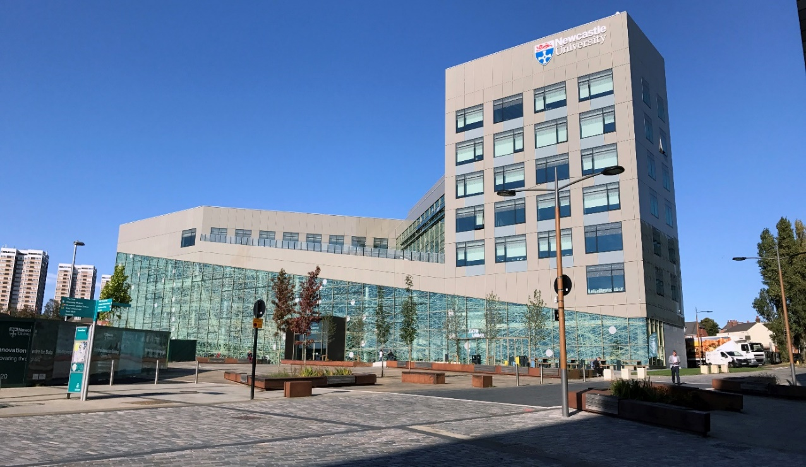

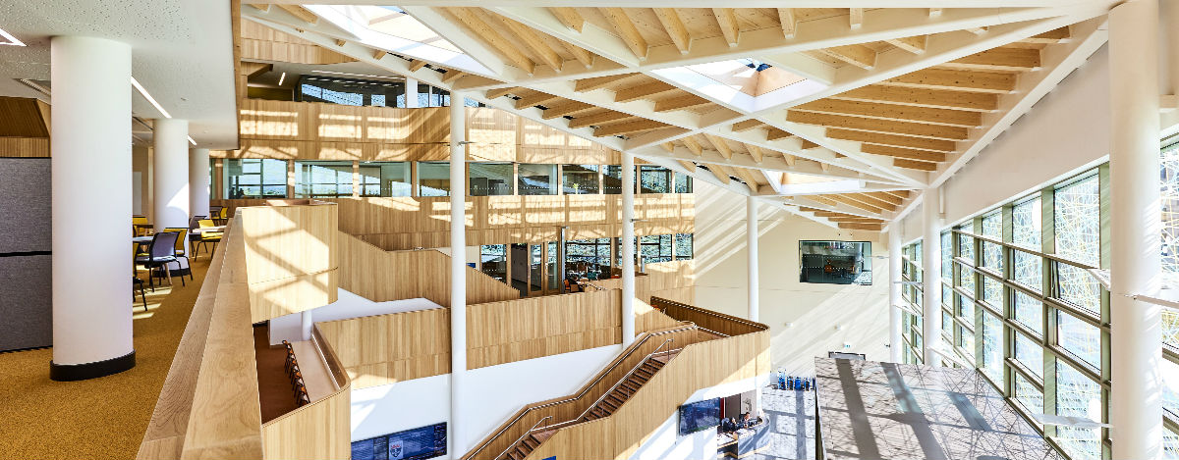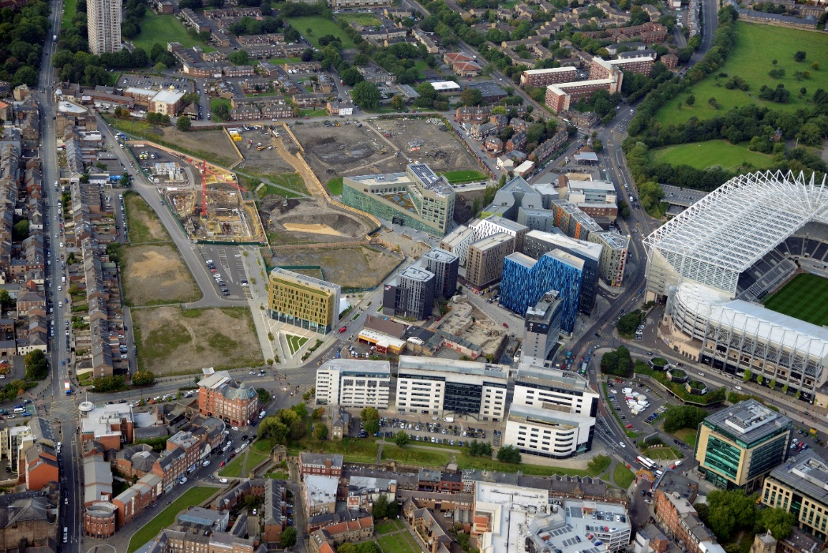

**Urban Sciences Building**

This building was successfully completed in August 2017 and received the first group of students the following September.

Images show the view of the frontage from Wellington Street (top), USB’s place in the rapidly developing Newcastle Helix site (right) and the vista across the main atrium space (below).